
Interconnecting all 3 Science strands

Teaching and learning that explores the intersection between all 3 strands gives students opportunities to build a rich and connected understanding of science concepts, apply scientific inquiry skills to investigate real-world issues, and appreciate science as a dynamic, human-driven enterprise that shapes and is shaped by society.

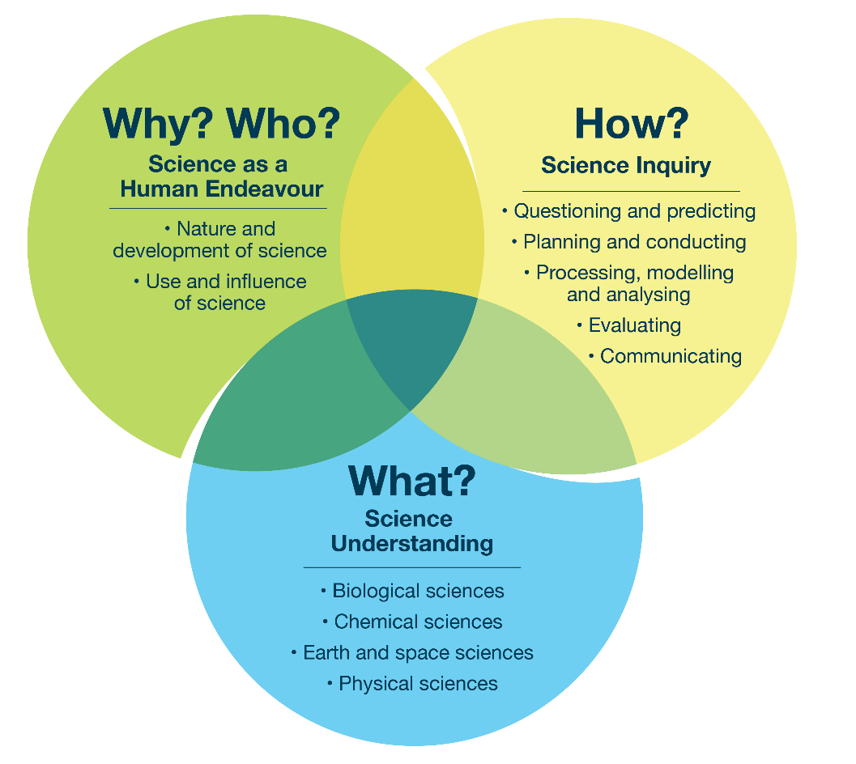
Focus 3.0 – Interconnecting all 3 Science strands

Example topic – multiple strands
During a teaching sequence about space exploration, students might examine the biological effects of space conditions on the human body, investigate how scientists design and test equipment for use on the Moon or Mars through hands-on activities, and discuss the impact of space exploration on our knowledge of Earth’s environment and society.
Possible focus question | Curriculum alignment
What conditions do astronauts face in space, and how do these affect their bodies? | H link: Considering how science helps humans survive and work in space environments  U link: Understanding human biology and space conditions (microgravity, radiation)  I link: Analysing data from experiments or simulations about human responses to space conditions  H–U–I overall link: Students investigate how human biology responds to space conditions, applying scientific knowledge and inquiry skills to analyse challenges and suggest ways to address them
Further examples on the next page.
Possible focus question | Curriculum alignment
How do scientists design and test equipment features that help equipment survive on the Moon or Mars? | H link: Exploring the role of innovation, problem-solving and collaboration in developing space technology  U link: Determining how scientists design and test features that help structures survive harsh space conditions  I link: Planning, testing and evaluating prototypes or simulations for space equipment  H–U–I overall link: Students apply physics and engineering to design and test space equipment models for safe use on the Moon or Mars
Possible focus question | Curriculum alignment
How has space exploration changed our understanding of Earth and its environment? | H link: Evaluating the impact of space science on society, policy and global environmental management  U link: Using satellite data to study Earth’s atmosphere, climate and ecosystems  I link: Collecting and analysing satellite data and images to monitor environmental changes  H–U–I overall link: Students assess how space exploration data, such as satellite images, contribute to our understanding of Earth and influence environmental actions

